# Setting Up Application Environment Create an Account in SendGrid

|  |  |
| --- | --- |
| **Team ID** | PNT2022TMID36945 |
| **Project Name** | Inventory Management System for Retailers |
| **Date** | 29 OCT 2022 |

**Step 1:**

Go to official SendGrid website: [***https://sendgrid.com/***,](https://sendgrid.com/) then click start for free.



# Step 2:

Then go to Registration Page, you need to give all the details required for creating a SendGrid account and finally click create button. The below screenshot will show the registration Process.

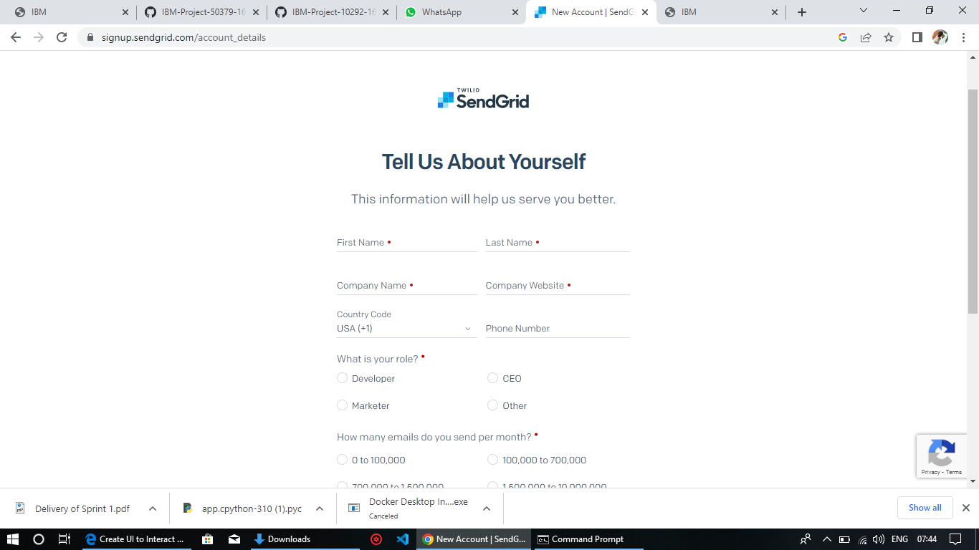

# Step 3:

Then it will redirect you to a home page of your SendGrid account.

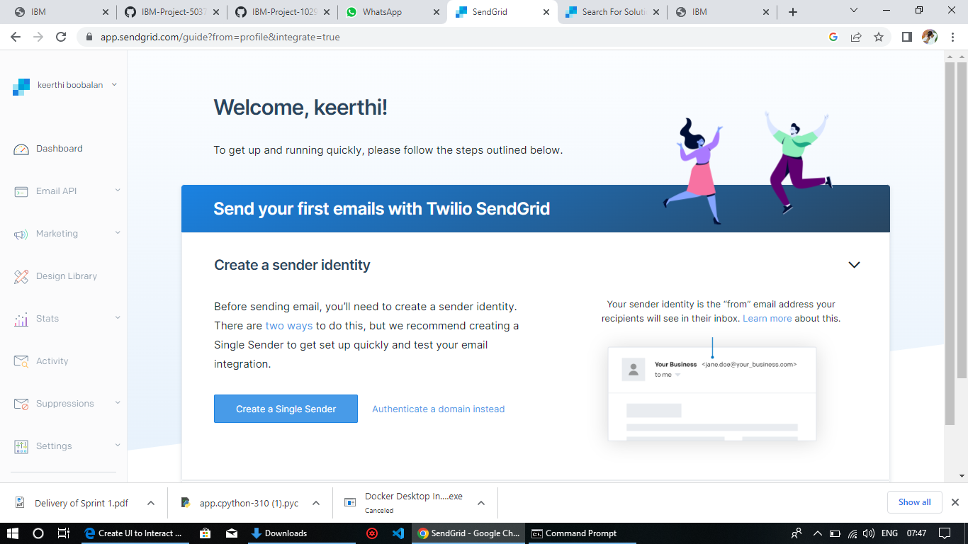

# Step 4:

Finally, you have created your account and now you can access the SendGrid account.